Social Media Basics: Senior Citizens  
Facebook

10 weeks/ 2-hour sessions

|  |
| --- |
| 1. Subjects will gain basic knowledge of social media and how to set up a profile   -Participants will get to choose from 3 modules: Facebook, Pinterest, or Twitter |
| 1. PowerPoint with audio or Prezi with in-hand printouts, take home materials and assignments to communicate with one another, signing a user agreement to insure appropriate use of the computers. |
| 1. A pre-test and post-test to measure growth of new knowledge and also simulations needed like messaging and communication to show gasp of social media basics. |
| 1. Introduction survey (pre-test), Facebook Group posts (weekly), 1-2 Facebook Live/Reflection papers, Infographic about Facebook (Internet Safety), Facebook Computer and Photo release, Kahoot (interactive) quiz –post-test, Certificate of completion |

## Project Background and Description

|  |
| --- |
| Introduction (Facilitator/Instructor): “Welcome to Social Media for Senior Citizens. We’re all here to learn, implement and understand the concepts and basics of Facebook.” Please don’t hesitate to ask any questions before, during or after this session. |
| Students (Pre-Test)   1. What do you already know about Facebook? Do you have an account already? 2. What do you want to learn? 3. Is this your first social media platform? Please share a reason you have registered to take this class. Include personal experience. |
| Image of Participants (Seniors): |
| Computer Lab Access and BYOD |

## Deliverables



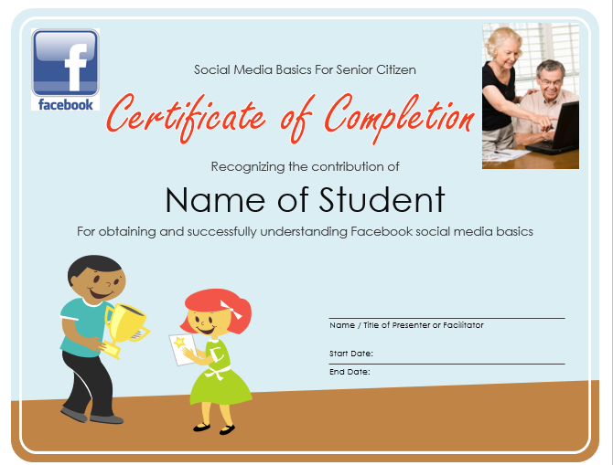

## Implementation Plan

0:00-0:15 10 min introduction/ refresher of last week if needed

0:15-0:30 Introduce new material – Week 1 defining social media and signing computer user agreement.

0:30-1:05 Group activity/ Simulation (Group size 2 adults)

- What to do if you forget your password/ reset? – if someone has access to your password they could pose as you.

1:05- 1:30 Questions/Concerns – One-on-one help

1:30- 1:45 Review and re-brief

1:45-2:00 Assign homework and leave time for questions

- One-on-one help or tutoring available 60 min before class starts.

## High-Level Timeline/Schedule

|  |  |
| --- | --- |
|  |  |

# Participation Sign Up

|  |  |  |
| --- | --- | --- |
| Name | Phone Number | Date |
|  |  |  |
|  |  |  |
|  |  |  |
|  |  |  |
|  |  |  |
|  |  |  |
|  |  |  |
|  |  |  |
|  |  |  |