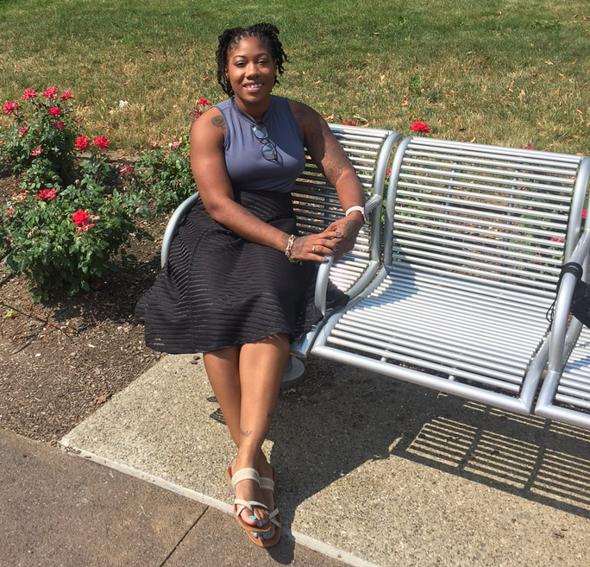 |  | EDUCATION
Wayne State University, Detroit MI
Master of Education- Learning, Design, Technology
May 2019 *Current GPA: 3.86
Coursework: Course Design, Layout & Design, Digital Writing

Wayne State University, Detroit MI
B.A. Public Relations, Minor in New Media
May 2017
Coursework: Blog Writing, News Editing, Social Media Writing

Wayne County Community College District- Downtown
Major: Business Administration
May 2016
Coursework: Typing, Speech, Microsoft Office Suite
Sharaya Solomon  Master of Education  Email: Sharaya.solomon@yahoo.com Phone: 248-579-3532  Profile  About Me: Detail oriented, People person, Reliable, Goal-getter  Skills: Video Editing, Adobe Captivate, Articulate, LMS Systems Blackboard & Canvas, Zoom, Hootsuite, Microsoft Office Suite  Interest: Writing, Networking, Fitness, Social Media  Volunteer Events: ’17 WSU MLK Bike Ride, Ralph Bunche Summer Institute, FASFA Fridays  WEBSITE:  https://solomonmedia.weebly.com/  LinkedIn: https://www.linkedin.com/in/solomonpr/ |  | WORK EXPERIENCE
Ren Cen Fitness - Front Desk Receptionist
June 2015–current
Downtown Detroit
Duties: Greeted members, prospective members and guests, providing exceptional customer service, handling all front desk related activities, guest memberships, clean and sanitize restrooms, fitness equipment and gym floor

Wayne State University Humanities Center
Data Entry & Social Media
August 2016–current
Duties: Created spreadsheets, verified data & Updating existing social media platforms (Facebook, Twitter & Instagram)

Wayne State HR Region B
Student Assistant
January –May 2016
Duties: Worked closely with the HR Manager to provide support as needed on highly confidential human resource matters and special projects. Maintain all electronic personnel/benefits files.
Work with new hires to collect necessary paperwork.

Internships:
Wayne State Department of Marketing and Communications
Fall 2017- Social Media Writer
WDET Public Radio 101.9 FM
Summer 2017- Digital Writer
Detroit, 48201
Grow Detroit’s Young Talent (GDYT) Intern
Vandyke & Horn Public Relations
January–May 2016
Fisher Building Detroit, 48202
Researching, evaluating data on a continuing basis, designing programs of action and communication to achieve the client’s necessary steps to the success of an organization’s aim

•References- Available upon request.

